RETAIL MARKET BASKET ANALYSIS FINAL REPORT
RETAIL MARKET BASKET ANALYSIS USING PYTHON
Minor Project Report
Submitted By
Name:Bonagiri geetha
College Name:CMR Technical campus(Autonomous engineering)
Internship Organization:SkillHigh
Department:CSE(Data science)
Academic Year: 2025-2026

Acknowledgement
I would like to express my sincere gratitude to my project guide and faculty members for their valuable guidance and support throughout the completion of this project.
I also thank my institution for providing the necessary resources and environment required to successfully complete this project.
I am grateful to the developers of Python and various open-source libraries such as Pandas, NumPy, and Mlxtend, which made this analysis possible.
Finally, I would like to thank my friends and family for their constant encouragement and support during the development of this project.

Abstract
Retail Market Basket Analysis is a data mining technique used to discover patterns in customer purchasing behavior by analyzing transaction data. The main objective of this project is to identify products that are frequently purchased together using the Apriori algorithm and association rule mining. The dataset used in this project contains 14,963 retail transactions with 167 unique products.
The data is preprocessed and converted into a transactional format suitable for analysis. The Apriori algorithm is applied to generate frequent itemsets based on support values, and association rules are derived using metrics such as confidence and lift. In this project, 126 frequent itemsets and 19 strong association rules were generated, revealing meaningful relationships between products such as grocery items often purchased together.
The results of this analysis help in understanding customer buying patterns and provide valuable insights for retail businesses. These insights can be used to optimize product placement, improve inventory management, design effective marketing strategies, and support cross-selling and recommendation systems. The project demonstrates how data analytics and machine learning techniques can be applied in the retail domain to enhance business decision-making and improve overall sales performance.

TABLES OF CONTENT
- Introduction
- Problem Statement
- Objectives
- Dataset Description
- Data Collection
- Data Processing
- Methodology
- Association Rule Mining (Apriori Algorithm)
- Tools and Technologies
- Results and Analysis
- Key Association Rules
- Visualizations
- Findings
- Insights
- Conclusion
- Future Scope
- Reference
Introduction
In today’s digital retail environment, businesses generate large volumes of transaction data every day. This data contains valuable hidden patterns that can help understand customer purchasing behavior. However, without proper analysis, this information remains unused and does not contribute to business decision-making.
Market Basket Analysis is a data mining technique used to discover relationships between items purchased together by customers. It helps identify which products are frequently bought in combination and reveals hidden associations in transaction data. One of the most popular algorithms used for this purpose is the Apriori algorithm, which works on the principle of frequent itemset generation and association rule mining.

In this project, retail transaction data is analyzed to identify frequently purchased products and generate meaningful association rules. The dataset consists of multiple grocery transactions where each transaction contains a set of items purchased by a customer. The data is preprocessed and converted into a suitable format for applying the Apriori algorithm.

The main goal of this project is to extract useful insights from retail data that can support business decisions. These insights can help retailers improve product placement, optimize inventory management, design promotional strategies, and increase overall sales through cross-selling techniques.

By applying data analytics and machine learning concepts, this project demonstrates how raw transaction data can be transformed into meaningful business intelligence that supports strategic decision-making in the retail industry.

Problem Statement
Retail businesses generate a large amount of transaction data on a daily basis due to continuous customer purchases. However, this data is often underutilized and not analyzed effectively to extract meaningful insights. As a result, retailers face challenges in understanding customer buying behavior and identifying relationships between products purchased together.
One of the major problems in retail management is the inability to determine which products are frequently bought in combination. Without this knowledge, businesses may miss opportunities for product bundling, cross-selling, and effective promotional strategies. Additionally, inefficient product placement and poor inventory planning can lead to reduced sales and customer dissatisfaction.
Traditional analysis methods are not sufficient to handle large-scale transaction data and discover hidden patterns. Therefore, there is a need for an efficient data mining approach that can analyze large datasets and extract useful association patterns between items.
This project addresses the problem by applying the Apriori algorithm to retail transaction data. The algorithm helps identify frequent itemsets and generate association rules that reveal strong relationships between products. These insights can support retailers in making data-driven decisions to improve sales, optimize store layouts, and enhance customer experience.

Objectives
The main objectives of this Retail Market Basket Analysis project are:
- To analyze retail transaction data and understand customer purchasing behavior.
- To identify frequently purchased products using data mining techniques.
- To apply the Apriori algorithm for generating frequent itemsets from transactional data.
- To discover association rules that describe relationships between different products.
- To measure the strength of relationships using support, confidence, and lift metrics.
- To identify product combinations that are commonly purchased together.
- To help retailers improve product placement and store layout based on buying patterns.
- To support cross-selling and upselling strategies through data-driven insights.
- To improve inventory management by identifying high-demand product combinations.
- To enhance marketing strategies by targeting related product groups.
- To demonstrate the use of Python and data analytics tools in real-world retail applications.
- To provide meaningful business insights that can improve overall sales performance and customer satisfaction.

Dataset Description
The dataset used in this Retail Market Basket Analysis project is a real-world grocery transaction dataset that contains customer purchase records. It consists of 14,963 transactions and 167 unique products, representing items commonly purchased in a retail grocery store.
Each row in the dataset represents a single transaction, where a customer has purchased one or more items together. The data is structured in a transactional format, where multiple products are listed in separate columns for each transaction. Some values in the dataset may contain missing entries (NaN), which indicate that fewer items were purchased in that particular transaction.
The dataset includes a wide variety of grocery products such as whole milk, yogurt, sausage, bottled water, vegetables, fruits, beverages, and other household items. These items reflect real customer purchasing behavior in a retail environment.
Before analysis, the dataset is preprocessed to remove missing values and converted into a suitable format for association rule mining. The transactions are transformed into a binary matrix using TransactionEncoder, where each product is represented as either present or absent in a transaction.
This dataset is well-suited for Market Basket Analysis because it captures real-world buying patterns and allows the application of data mining techniques like the Apriori algorithm to discover frequent item combinations and association rules.
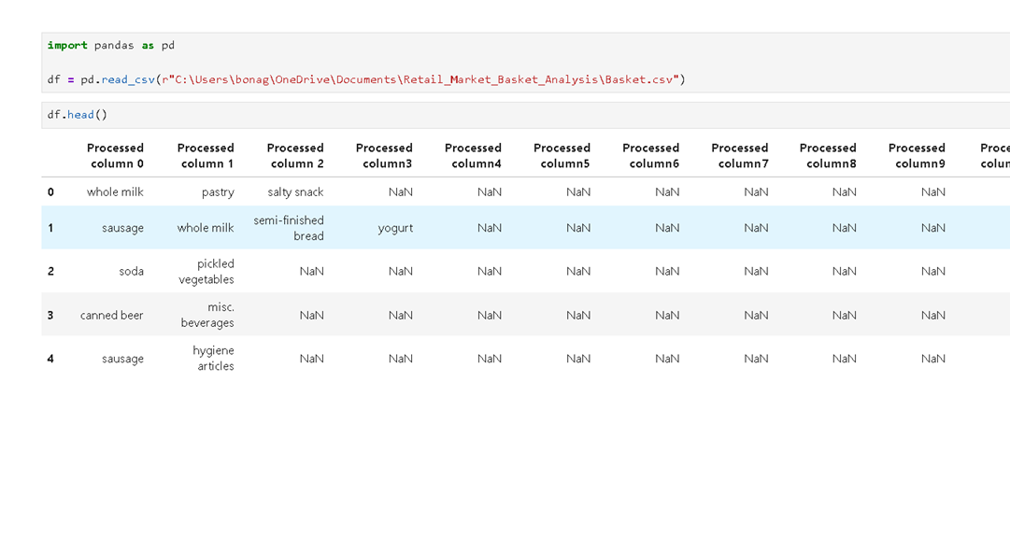

Methodology
The methodology of this Retail Market Basket Analysis project involves a structured process of data preprocessing, transformation, and application of data mining techniques to extract meaningful patterns from retail transaction data.
1.DataCollection
The dataset used in this project consists of retail grocery transaction data containing 14,963 transactions and 167 unique products. Each transaction represents a set of items purchased by a customer.
2.DataPreprocessing
The raw dataset is first cleaned by handling missing values (NaN entries). Irrelevant or empty values are removed to ensure data quality. The dataset is then transformed into a suitable format for analysis.
3.TransactionFormation
Each row in the dataset is converted into a transaction list, where all purchased items in a single transaction are grouped together. This step helps in structuring the data for association rule mining.
4.TransactionEncoding
The TransactionEncoder from the Mlxtend library is used to convert the list of transactions into a binary matrix format. In this matrix, each column represents a product, and each row represents a transaction. The values are represented as True or False (or 1 and 0), indicating whether a product was purchased in a transaction.
5.FrequentItemsetGeneration
The Apriori algorithm is applied to the encoded dataset to identify frequent itemsets. This step uses a minimum support threshold to filter out less frequent item combinations and retain only significant itemsets.
6.AssociationRuleMining
After identifying frequent itemsets, association rules are generated using metrics such as support, confidence, and lift. These rules help in understanding the strength and direction of relationships between different products.
7.AnalysisandVisualization
The generated rules and itemsets are analyzed using visualizations such as bar charts and scatter plots. These visualizations help in interpreting product relationships and identifying key patterns in customer purchasing behavior.
8.InterpretationofResults
The final step involves interpreting the results to derive meaningful business insights. These insights help retailers in improving product placement, inventory management, and marketing strategies.

Data Collection
The data used in this Retail Market Basket Analysis project is a secondary dataset collected from a publicly available retail grocery transaction database. The dataset represents real-world customer purchase records from a retail store and is widely used for market basket analysis and association rule mining studies.
The dataset contains a total of 14,963 transactions, where each transaction represents a unique shopping instance of a customer. Each transaction includes multiple grocery items purchased together. The dataset includes 167 unique products, covering a wide range of grocery items such as dairy products, vegetables, beverages, bakery items, meat products, and household goods.
The data is typically stored in a structured tabular format, where each row represents a transaction and columns represent items purchased in that transaction. Since customers may purchase varying numbers of items, some entries contain missing values (NaN), which indicate the absence of additional items in that transaction.
The dataset was obtained from an open-source platform and is commonly used for educational and research purposes in data mining and machine learning applications. It provides a realistic representation of retail purchasing behavior, making it suitable for applying association rule mining techniques like the Apriori algorithm.
This dataset was selected because it is clean, well-structured, and appropriate for identifying frequent itemsets and discovering meaningful relationships between products in a retail environment.

The Groceries dataset was collected and imported into Jupyter Notebook.

Data Preprocessing
Data processing is a crucial step in the Retail Market Basket Analysis project, as it transforms raw transactional data into a structured format suitable for applying data mining techniques such as the Apriori algorithm.
Initially, the dataset is loaded into the Python environment using the Pandas library. The raw dataset contains multiple columns representing items purchased in each transaction, along with missing values (NaN) where fewer items were bought.
The first step in data processing involves handling these missing values. All NaN entries are identified and excluded from the transaction lists to ensure that only valid product items are considered. This helps maintain data accuracy and consistency.
Next, the dataset is transformed from a tabular format into a transactional format. Each row is converted into a list of items representing a single customer transaction. This step is essential because association rule mining algorithms require data in transaction form rather than structured columns.
After forming transactions, the TransactionEncoder from the Mlxtend library is applied. This encoder converts the list of transactions into a one-hot encoded binary matrix. In this matrix, each column represents a product, and each row represents a transaction. The values are represented as True or False (or 1 and 0), indicating whether a product is present in a given transaction.
Once encoding is completed, the dataset becomes suitable for applying the Apriori algorithm. The processed data ensures that each product is properly represented, enabling efficient identification of frequent itemsets and association rules.
Finally, the processed dataset is validated by checking its structure, dimensions, and sample records to ensure correctness before proceeding to the analysis phase.

- Removed missing values.
- Converted transactions into list format.
- Applied TransactionEncoder to create a binary matrix.
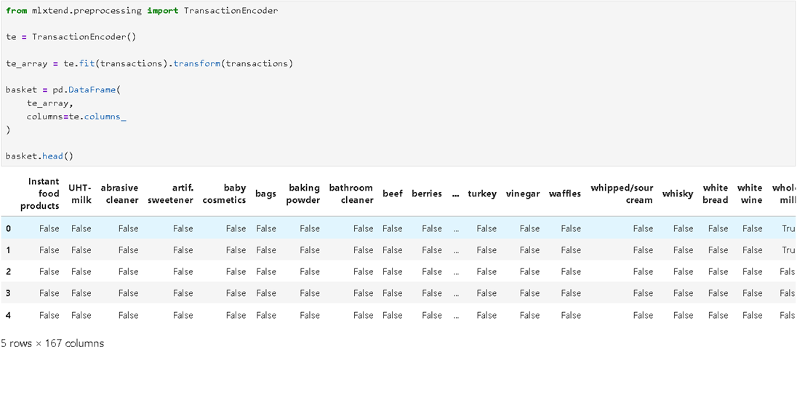

Apriori Algorithm
The Apriori algorithm is a fundamental data mining technique used for discovering frequent itemsets and generating association rules in large transactional datasets. It is widely used in Market Basket Analysis to identify relationships between items purchased together.
The algorithm operates on the principle that if an itemset is frequent, then all of its subsets must also be frequent. This property is known as the Apriori principle, which helps in reducing the search space and improving computational efficiency.
Steps of the Apriori Algorithm:
1.InputDatasetPreparation
The transactional dataset is prepared, where each transaction consists of a set of items purchased by a customer.
2.SetMinimumSupportThreshold
A minimum support value is defined to filter out infrequent itemsets. Only itemsets that satisfy this threshold are considered frequent.
3.GenerateFrequent1-Itemsets
The algorithm first scans the dataset to find all individual items that meet the minimum support requirement.
4.GenerateCandidateItemsets
Frequent itemsets are combined to form larger candidate itemsets. For example, frequent 1-itemsets are combined to form 2-itemsets, and so on.
5.PruningStep
Itemsets that do not satisfy the minimum support condition are removed. This reduces unnecessary computations.
6.IterativeProcess
The process of generating candidate itemsets and pruning continues until no further frequent itemsets can be formed.
7.AssociationRuleGeneration
Once frequent itemsets are identified, association rules are generated using metrics such as:
- Support: Measures how frequently an itemset appears in the dataset.
- Confidence: Measures the likelihood of occurrence of the consequent given the antecedent.
- Lift: Measures the strength of association between items.
8.RuleEvaluation
Rules are evaluated based on minimum confidence and lift thresholds to identify strong and meaningful associations.
Advantages of Apriori Algorithm:
- Simple and easy to implement
- Reduces search space using pruning
- Effective for small to medium-sized datasets
Limitations:
- Computationally expensive for large datasets
- Requires multiple database scans
- Performance decreases with dense datasets
The Apriori algorithm is widely used in retail analytics to identify product associations and improve business decision-making.
Results and Analysis
The Retail Market Basket Analysis project successfully applied the Apriori algorithm to analyze customer transaction data. The dataset contained 14,963 transactions and 167 unique products.
After preprocessing and applying the Apriori algorithm, a total of 126 frequent itemsets were generated based on minimum support criteria. From these itemsets, 19 strong association rules were extracted using confidence and lift thresholds.
The analysis revealed several important patterns in customer purchasing behavior. It was observed that certain products frequently appear together in transactions. The presence of strong associations between grocery items indicates that customers tend to purchase related products in combination.
Visualization techniques such as bar charts and scatter plots were used to better understand product relationships and support business decision-making.
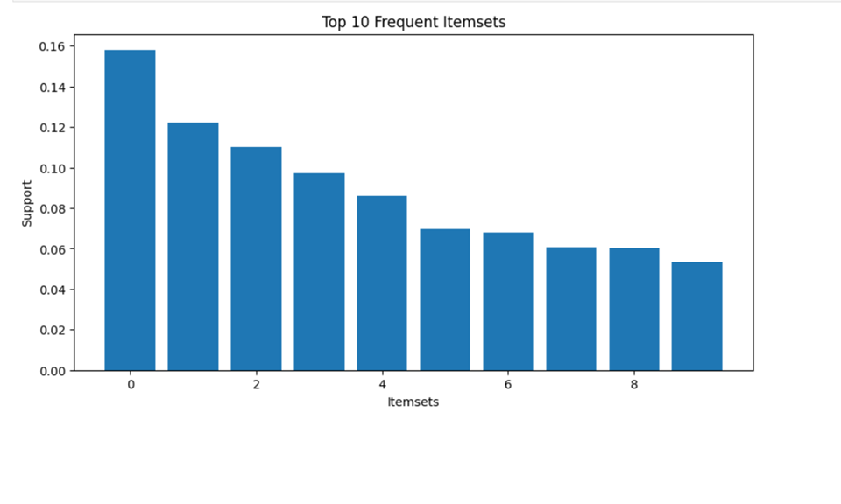
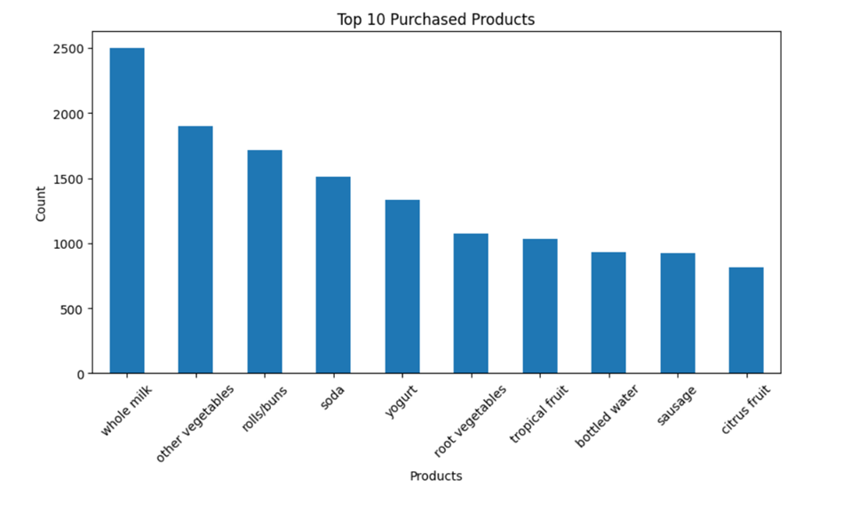
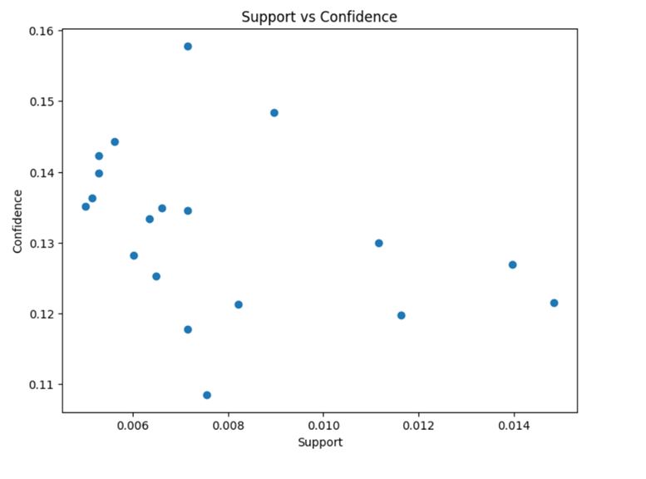
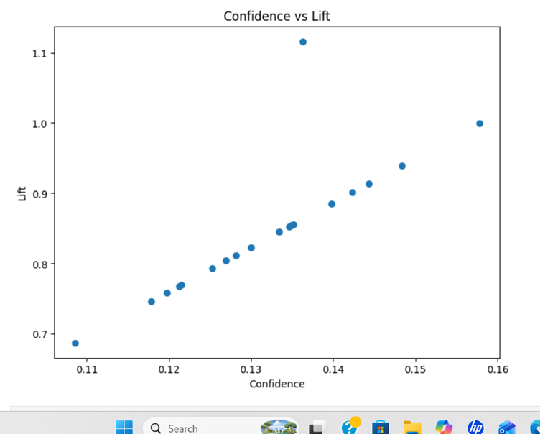

Key Association Rules
Some of the important association rules discovered in this project include:
- Frankfurter → Other Vegetables
- Bottled Beer → Whole Milk
- Sausage → Whole Milk
- Citrus Fruit → Whole Milk
- Shopping Bags → Whole Milk
- Domestic Eggs → Whole Milk
- Pip Fruit → Whole Milk
- Pork → Whole Milk
These rules indicate that Whole Milk is a frequently purchased item and appears in multiple associations, making it a key product in customer transactions.
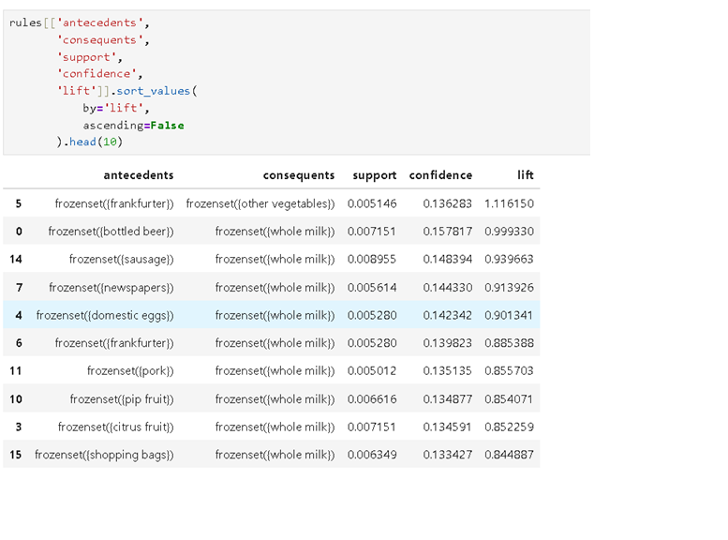
Tools and Technologies
The following tools and technologies were used in this project:
- Python: Primary programming language used for data analysis and implementation of algorithms.
- Jupyter Notebook: Interactive environment used for writing and executing code.
- Pandas: Used for data manipulation and preprocessing.
- NumPy: Used for numerical computations.
- Mlxtend Library: Used to implement Apriori algorithm and association rule mining.
- Matplotlib: Used for data visualization.
- Seaborn: Used for enhanced statistical visualizations.
- Power BI: Used for creating interactive dashboards and visual reports.
These tools collectively help in performing efficient data preprocessing, analysis, visualization, and interpretation of results.
Findings
- Whole milk is the most frequently associated product in the dataset.
- Customers often purchase complementary grocery items together.
- Certain products show strong association patterns with others.
- A total of 126 frequent itemsets and 19 association rules were identified.
- Market Basket Analysis helps in identifying hidden patterns in customer behavior.
- Retailers can use these insights for product placement and marketing strategies.
- Association rules help improve cross-selling and promotional planning.
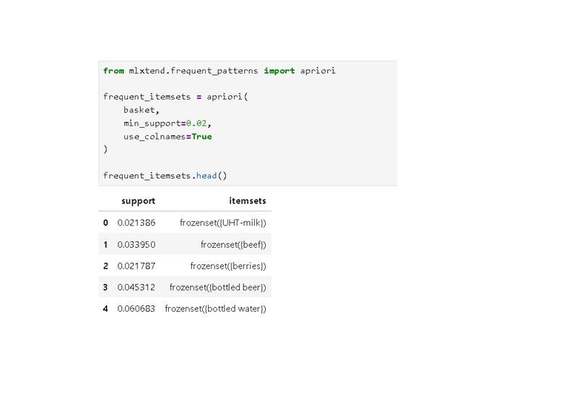
Insights
- Whole milk is the most frequently associated product in customer transactions.
- Customers often purchase complementary items such as vegetables, dairy products, and beverages together.
- Products like frankfurter, sausage, and citrus fruit show strong associations with other grocery items.
- Association rules help identify hidden patterns in customer buying behavior.
- Retailers can increase sales by placing related products closer to each other.
- Cross-selling opportunities can be improved using frequent itemset analysis.
- Product bundling strategies can be designed using strong association rules.
- Customer purchasing behavior is highly influenced by commonly used grocery items.
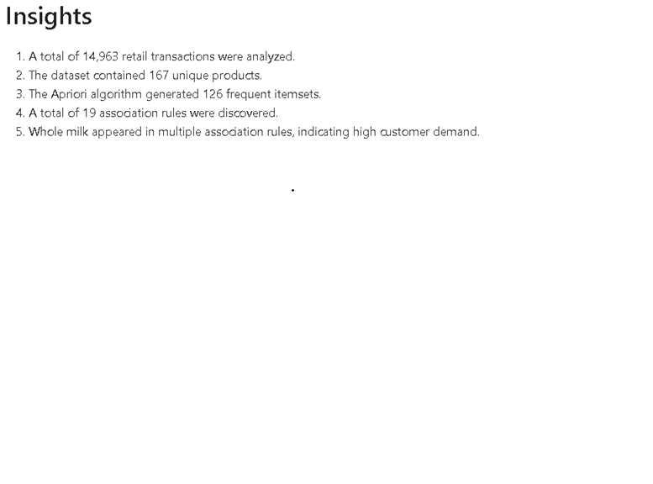

Conclusion
- The Retail Market Basket Analysis project successfully demonstrated the application of the Apriori algorithm in discovering meaningful patterns in retail transaction data. The analysis helped identify frequent itemsets and strong association rules that represent customer purchasing behavior.
- The results show that certain products are frequently bought together, providing valuable insights for retailers. These insights can be used to optimize product placement, improve inventory management, and enhance marketing strategies.
- Overall, the project highlights the importance of data mining techniques in transforming raw transactional data into actionable business intelligence.
Future Scope
The project can be extended in the following ways:
- Implementation of FP-Growth algorithm for faster processing of large datasets.
- Development of a real-time recommendation system for customers.
- Integration with e-commerce platforms for personalized suggestions.
- Use of larger and more complex datasets for improved accuracy.
- Deployment of interactive dashboards using Power BI or Tableau.
- Application of machine learning techniques for predictive analytics in retail.
References
- Pandas Documentation – https://pandas.pydata.org
- NumPy Documentation – https://numpy.org
- Mlxtend Library Documentation – http://rasbt.github.io/mlxtend/
- Matplotlib Documentation – https://matplotlib.org
- Association Rule Mining and Apriori Algorithm Research Papers
- Jupyter Notebook Documentation – https://jupyter.org
- Microsoft Power BI Documentation – https://powerbi.microsoft.com

